**Ashington Vocal Summer 2025 Edition**

Welcome to the fifth edition of Ashington Vocal, the newsletter of Ashington & District Male Voice Choir.

The newsletter, which will normally be produced quarterly, is aimed at keeping the community, patrons and stakeholders better informed about what is going on or will be happening in the Choir. You will automatically receive future editions, unless you opt out.

Each newsletter will also be posted in a sub-section under ‘News’ on the Choir website, https://www.ashingtonmalevoicechoir.org.uk.

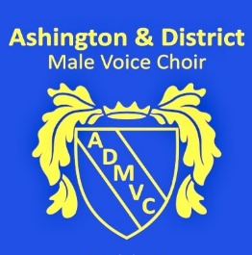

The Management Committee has been focused on continuing the work Kevin Lillie began since his resignation from the choir in early July.

Chairman George commended the work, effort and enthusiasm that Kevin had brought to the choir and in particular his role within the Management Committee and the Ashtones.

**New Members are welcomed** A huge welcome to Michael Fagbore, Tom Bone, Tim Court and Nathan Gulliver our newest members we hope you all continue to enjoy singing with the choir.

**Our Annual Visit to Beamish**Our now established yearly visit was a particularly well supported and great performance wise, it was a pity we did not get a chance to complete our full second half, however feedback from Staff and Visitors was very complimentary and since then video footage has vastly increased Facebook interest.

**New Songs** Neil Morton our Musical Director has been hard at work and produced four songs **Glossy Black Diamonds**, **Flow,** and **Heroes of Our Team** which, tells the story of some of Ashington’s Sporting Heroes, with song four **Family** almost ready, a nostalgic look at life and community these are ready now for the choir rehearsals and form part of our **Heritage Suite** especially commissioned by the choir to celebrate 110 years since being founded in 2026.

**Heritage Concert 2026** Plans for the are well underway and we have secured Graeme Danby as our guest artist, fortunately the choir has been able to secure some funding for this project from the Community Foundation.

The Heritage Concert on 21 March 2026 will be a great opportunity to raise the choir profile even more and hopefully attract more new members, in July the Management Committee decided to go ahead with the purchase of new blazers. This is a huge cost to the choir and funding was sought in the form of Grants available from several sources. Luckily ADMVC have secured to date £2000 from the Barbour Foundation, £2500 from the Sir James Knott Foundation with a further application of £1400 with Ashington Town Council pending.

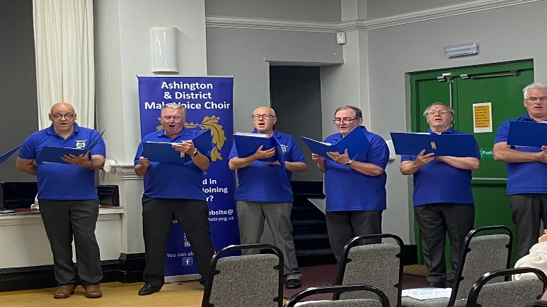

**Ashtones** Are live and ready to perform for you with new equipment which was grant funded from, Choppington Parish Council the Ashtones have started to contribute to the Choirs Concert Schedule. They already have bookings for Christmas and into 2026. Look out for their performances in the Blyth Celebrates Program.

**Summer School** Further to members request the MC arranged for three weeks of singing for fun with a smattering of learning, this period traditionally would be quite a long summer break and some members felt they were missing out on the comradeship so step in Declan Flannery who very successfully ran these sessions.

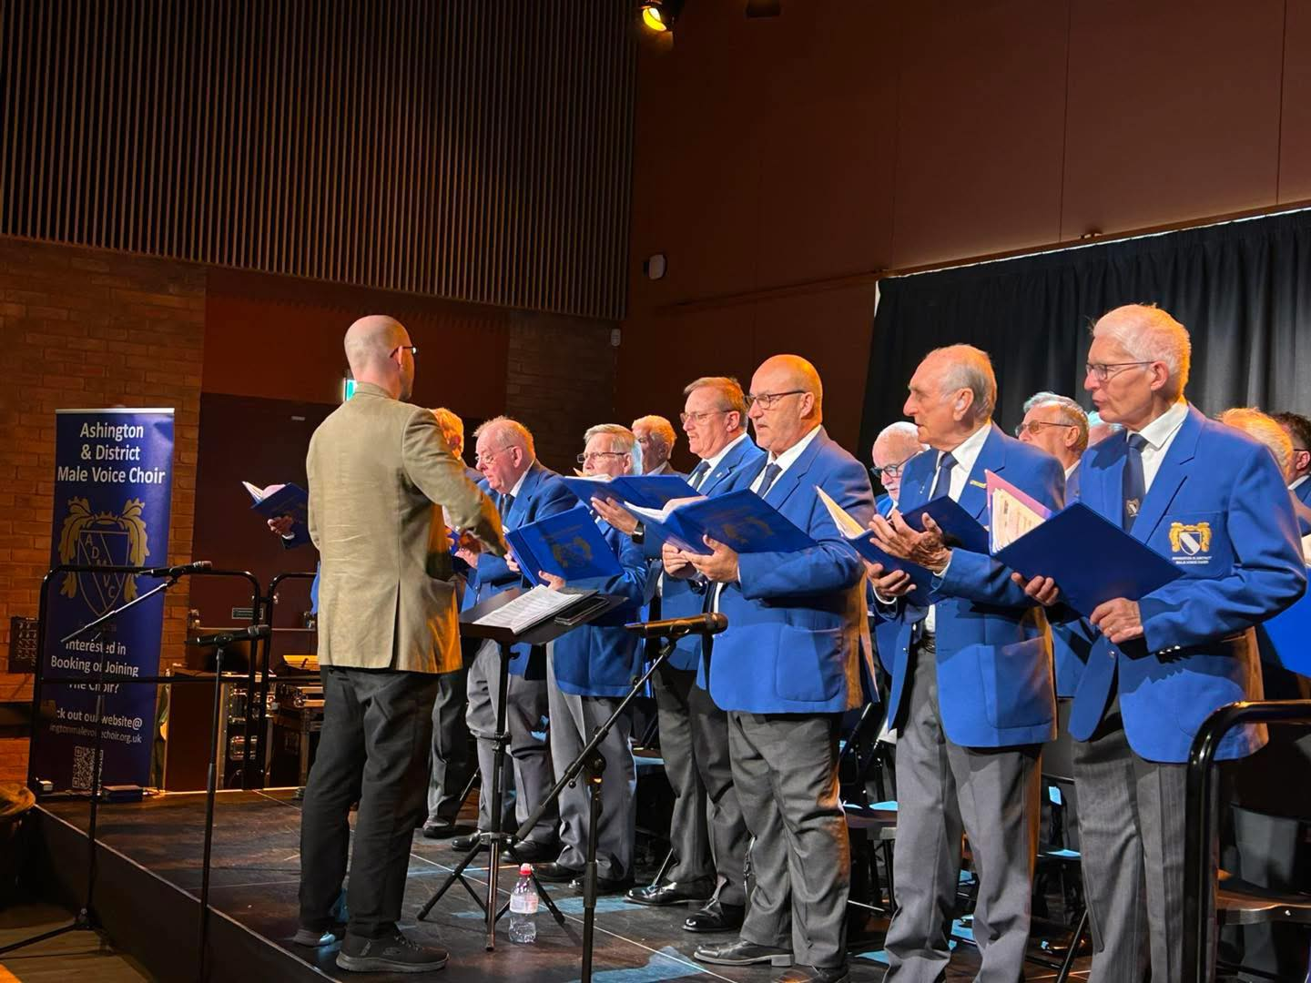

**Blyth Celebrates** Our first event 24 August Concert in Studio 25 as part of a recruitment and performing arts drive in Blyth, organisers confirmed was attended by 186 people.

Blyth Celebrates is a great opportunity for the choir to reach new audiences and hopefully recruit new members Studio 25 is a very modern performing space in the heart of Blyth Market Pavilion and the choir is looking forward to its next outing on 13th September when the choir will perform some vintage musical favourites such as Can’t Help Falling in Love, Some Enchanted Evening and Unchained Melody.

C Prow Aug 2025